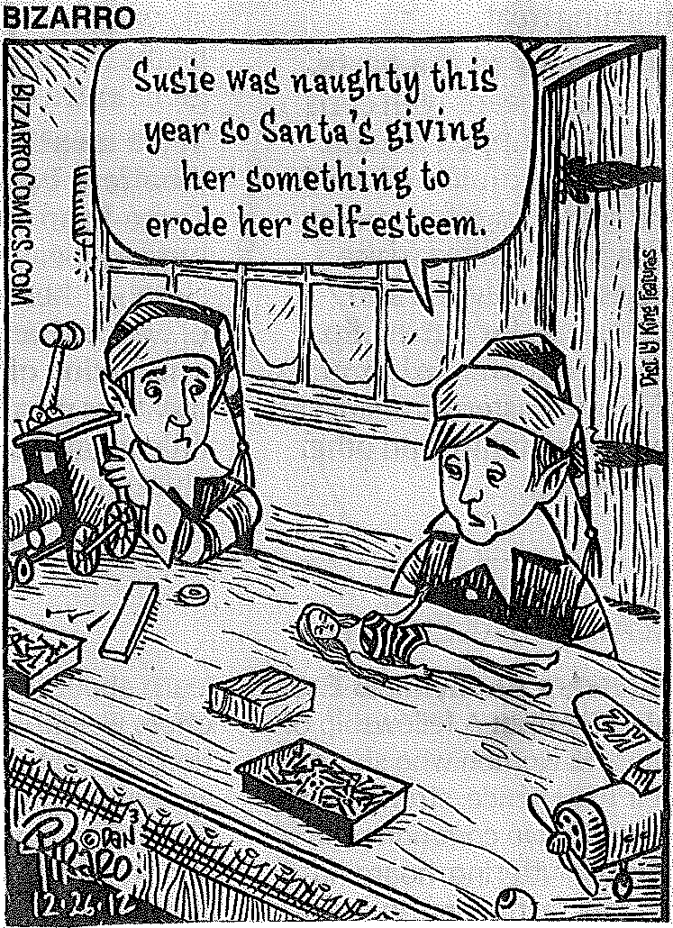
Genders and Sexualities
Sinq 231G

Winter 2013

Instructor: Leslie W. Batchelder,
PhD
Office: D117 Cramer Hall Email: moran2@pdx.edu
email: lwbatch@pdx.edu
Office Hours: Mon. 12-1pm,
Thurs. 3:30-4:30 and by
Appointment. Mentor: James Moran
email: moran2@pdx.edu
Course Description:
In this inquiry course we will examine the many expressions or performances of sexuality and gender that inform our understandings of what gender and sexuality are, and how they in turn construct our identities, behaviors and beliefs. As the authors of our text The Sexuality of Gender note:
There are probably no two areas---gender and sexuality---with more taken-for-granted stereotypes and more armchair experts to expound upon them. Furthermore, there was only limited recognition that when people talk about gender, they often imply things about sexuality and when they talk about sexuality they make assumptions about gender.

Our task will be to study and interrogate some of these stereotypes and assumptions to better understand how gender and sexuality function in our lives as individuals and in our society as a whole.

On Inclusion and Respect:

One of the goals of this course and indeed this University Studies cluster is to “create a collaborative and mutually beneficial learning environment.” In other words a learning community in which everyone feels respected and included. Therefore we should make every effort to make sure everyone is heard and respected. At times issues surrounding gender and sexuality can be fraught with emotional reactions brought on by deep-seated beliefs and/or feelings. Each of us has our own unique response to these issues and as a learning community we should make every effort to respect the right of each individual to express themselves. We want to be sure the classroom is a safe space for exploring sexuality and gender for all students. This requires that everyone, including the instructor, maintain an open mind and willingness to listen.

Learning Objectives:
- Begin to recognize some of the constructs of gender, race, class, sexuality, religion, ability and nation as well as their intersecting relationships with regards to gender and sexuality.
- Explore and contextualize the meaning of our social identities, historically, politically and personally.
- Begin to apply our understanding of these ideas to our political practices, intellectual endeavors and personal communities.
- Work together to create a collaborative and mutually beneficial learning environment.
- Acquire critical thinking and communication skills through our written and oral practices.

Required Text:
The Gender of Sexuality by Virginia Rutter and Pepper Schwartz. Second edition. Rowan & Littlefield, Lanham Maryland, 2012
Available at PSU bookstore

Course Policies
This is a Cell phone free zone!
Please either turn off or set all electronic devices to vibrate. This includes all blackberries, pagers, computers etc. A classroom is much like a theater in which others are paying for a ticket and expect your courtesy. Phones and other devices can be very disruptive and therefore do not belong in the classroom. Please identify yourself to the class if you are using a Smartphone to read an online text or using the phone to save notes to yourself. If using a computer during class is a necessity for you, i.e. you have a disability, please see me.
Participation
This course is part of the University Studies program and as such it requires active student participation. A deliberate attempt is made in this course to modify the traditional institutional model of students as passive participants in a lecture. On the contrary, my expectation is that you will actively participate. This means not merely showing up and occasionally talking, but rather that you take the time to carefully and thoughtfully prepare all readings for the day which they are assigned and come to class ready to discuss them in a thoughtful manner. Participation also entails consistent and meaningful participation in mentor sessions.
© Plagiarism
Using another person’s thoughts, ideas or words without properly crediting that person is known as plagiarism. PSU has a well-defined policy regarding plagiarism, cheating or academic dishonesty (see “Student Rules of Conduct” in PSU bulletin). Plagiarism will result in a grade of F. We will have more instruction and discussion of this issue in mentor session.

The Right to be successful: Students with disabilities, who may require accommodations, are encouraged to contact the PSU Disabilities Resource Center and the professor at the beginning of the term to arrange accommodations.

All graded written work can be picked up at my office CH D117 by April 15 2013. After this date it will be shredded and recycled.

Are We In Sinq?
This class is conceived as part of the University Studies program. As such it is designed to help students to make progress towards the four goals of University Studies:
~Critical Thinking and Inquiry ~Communication
~Ethical and Social Responsibility ~Diversity of Human Experience
The University Studies Program is a unique General Education program designed to provide students with more holistic and integrated college experience. The program stresses student centered learning, developing a sense of community amongst students and community based learning.
In this course several assignments are designed with specific goals in mind such as the Group Presentation (Ethical and Social Responsibility & Diversity of Human Experience).
Description of Assignments:

Reading Response Journal 25% of grade
Reading Journal. For each class discussion you will need to complete the reading journal/”pick a passage” assignment. This assignment is comprised of your ongoing “Pick a Passage” posts on D2L. These posts serve as a weekly “quiz” in lieu of a midterm. All reading journals are due at 10 am on the day we will discuss them in class.

Participation 15% of grade
Participation in course and mentor session. Active participation is expected. Lateness, absences, or lack of participation will affect your grade. Note that 15% of your grade is participation. You will be graded not only on attendance but also on the quality of your participation. Likewise mentor sessions can be profoundly instructive and helpful if you show up and engage.

The Art(-iface )of Gender and Sexuality Research Proposal and Project Description 15%
To facilitate a polished end product you will produce a short (one page) summary describing your project accompanied by an annotated bibliography.
Art-(iface) of Gender/Sexuality Research Project 25%
This is both an art project and a critical thinking exercise. Create a work of art that expresses an aspect of gender or sexuality that is most meaningful, intriguing or compelling to you. Keep in mind that the main purpose of this course, and indeed our discussions, is to dispel myths and stereotypes about gender and sexuality.
For example, if you are creating an action figure you could use a standard Barbie or other doll as your canvas. Using this doll you can create a new Figure that questions assumptions or gender/sexuality or parodies hegemonic conceptions of gender/sexuality. In your written analysis you would explain how/why your action figure deconstructs mainstream assumptions about gender and/or sexuality. What sociological, economic or political issues play into your re-presentation of gender and/or sexuality?
You can create:
  - a short video**
  - an “Action Figure”
  - painting or drawing composition.
  - a manga or comic book **
**You may choose to do this as a collaboration with one or two other students (Two maximum) or as an individual artist.
Your artwork will be accompanied by an analysis essay (1,200 -1,400 words) that explains your artwork and it’s relevance to creating a deepening understanding of how gender and sexuality are deployed in our society. What are the ideas or metaphors that inform your vision? What is the relevance of your artwork to our text, The Sexuality of Gender or our discussions? How does your artwork reflect broader discussions of the issue you are attempting to capture in your artwork? You must also include three additional sources two of which must be scholarly.

Portland Gender/Sexuality Activism Presentation 20%
Students will work in teams of four or five to research a Gender or Sexuality activist group in the Portland area. What services does this group provide? When were they founded and by whom? What issues do they see as most important? What is their mission? What are their plans for the future? HINT: Contact the group you are interested in ASAP!!! Non-profit and community organizations are notorious for being overburdened with work so they may not get back to you right away.
Each group will give a 15 minute PowerPoint or website presentation at the end of the term. In order to work on presentations during mentor section you should pick team members who are also in your mentor group. Each group will present on a different topic so you will need to sign-up for a topic with James in order to avoid any duplications.

Gender and Sexualities Class Sessions Calendar
Date/Time | Topic/Reading | Mentor
Mon. 1/7 | What are “Gender” and “Sexuality” and why study them? | What do you know and what do you want to know?
Weds. 1/9 | Film  Middle Sexes
Mon 1/14 | Rutter & Schwartz 1-20  Assign Research Project | Academic Writing  MLA style, mechanics etc.
Weds 1/16 | Rutter & Schwartz 21-44
Mon 1/21 | MLK HOLIDAY PSU CLOSED | Check in Assignment with Mentor/me
Weds 1/23 | Library session focused on your research project
Mon 1/28 | Rutter & Schwartz 45-69  Assign Presentation | Group work and contract  Arti-face Project Proposal and Annotated Bibliography are due!
Weds 1/30 | Rutter & Schwartz  70-88
Mon 2/4 | Rutter & Schwartz 89-121
Weds 2/6 | Rutter & Schwartz 122-150
Mon 2/11 | Rutter & Schwartz 151- 176
Weds 2/13 | Film
Mon 2/18 | Rutter & Schwartz 178-194
Weds 2/20 | Rutter & Schwartz 195-220
Mon 2/25 | Film | Work on Presentations
Weds 2/27 | Rutter & Schwartz 221-240
Mon 3/4 | TBA | Peer Review of Project Paper
Weds 3/6 | Presentations
Mon 3/11 | Presentations | Research Project and Paper is due
Weds 3/13 | Presentations
FINAL | Festival of Projects
Guidelines for preparing your reading responses
Each response/entry should be 200-400 words.

In this assignment we are practicing the skill of “critical reading.” That is, reading not only to get the gist of something but also to develop a deeper understanding of the text and connections between what we read and the world around us.

Your response should be a thoughtful and engaging piece of writing, written in an analytical style (as opposed to less formal writing) Therefore, an analytical reflection process should be evident in your entry for each reading. I envision your response journal entries in two ways: 1. You pick a passage to respond to. 2. You write a critique that you could possibly share with the authors.

1. For this option you would pick a passage you find most compelling, interesting or even confusing and explain how/why you have chosen the passage and your thoughts about it. You should choose a specific idea or passage to analyze. You can do this in several ways. For example, you could relate the passage idea to an experience in your own life, (being sure to use analytical language) or you could simply do a close reading of the passage looking at the way in which Rutter and Schwartz deploy language and ideas to make their point.
- You write a short critique of a specific part of the text (such as a chapter or section) that could be shared with the authors of this text. Therefore you should address the authors directly. It is important to inform them as to what would have been helpful. What you want to know and why.

General comments on style

Consider the following paragraph:

i really liked the part about women and god. She made some really good points. Like how god is a man. I don’t know very much about colonialism but it sounds interesting. She goes off on lots of tangents but i think i understand most of it.

As you will no doubt note, you now know absolutely nothing about the author or her text. In fact the paper could be about any number of authors and texts. Attributes like “really good” don’t actually clarify your thoughts about the content you have read or indeed say much of anything at all. Your goal is to be a critical thinker. This means you should employ language that is much more precise and illuminating. Consider the following passage:

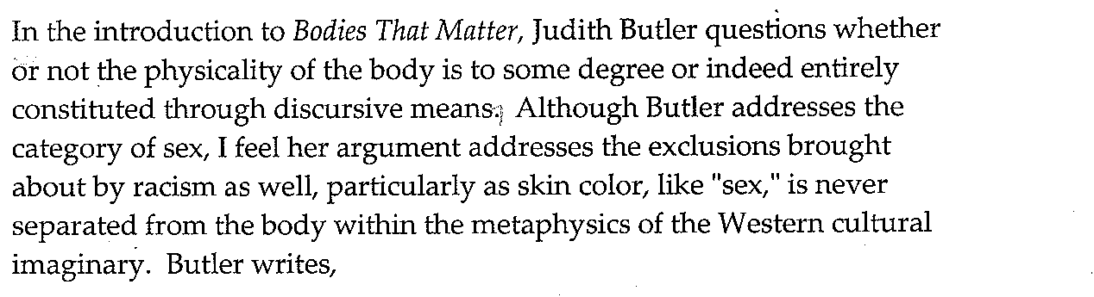

The category of “sex” is, from the start normative; it is what Foucault called a
regulatory ideal.” In this sense, then, “sex”, not only functions as a norm, but is part of a regulatory practice that produces the bodies it governs, that is whose regulatory force is made clear as a certain kind of productive power, the power to produce—demarcate, circulate, differentiate—the bodies it controls.

Likewise, “race”, also functions as a “regulatory ideal.” In Race and the Education of Desire: Foucault’s History of Sexuality and the Colonial Order of Things, Ann Laura Stoler makes a strong argument for race as constituative of the modern bourgeouis European subject (and body)

Note that this passage gives you both the names of the authors being discussed, the names of the texts being discussed and the writer’s response. The writer adapts and deploys some of the very language used by the authors she is quoting in her own argument. In your responses you should strive to be more like the latter example than the former. Many of you may feel you are as yet not ready to engage on the level produced above. However, this does not mean you should not try to practice these skills. The model above is simply that, a model for how a writer can write about a text.

Judith Butler. Bodies That Matter. (New York: NY, Routledge, 1993)
Ann Laura Stoler, Race and the Education of Desire: Foucault’s History of Sexuality and the Colonial Order of Things (Durham, NC: Duke University Press, 1996)

