Interpreting the Past:
Modernity and Identity
UNST 236G: The 19 CENTURY
Fall 2013
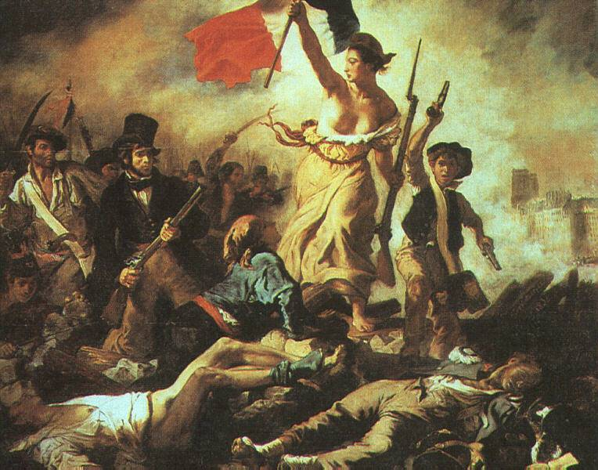
Instructor: Leslie W. Batchelder, PhD
Email: lwbatch@pdx.edu
Mentor: Erika Schnatz
Email: eschnatz@pdx.edu
Main Class: 2-3:15 T/R
Office: Cramer D117
Office Hours:
And by Appointment.

Lady Liberty leading the people, Delacroix 1830

Course Description:
This course focuses on the 19th Century as it has been studied, construed and constructed through the interpretation of various artifacts and events of the time such as music, education theory, scientific theories and famous cultural figures. In this class we will examine the culture of the Nineteenth century as the crucible of Modernity in which visual culture including photography, advertising, the public spectacles and urban cityscapes played a crucial role in shaping experience. We will discuss how artifacts of 19th century culture in turn helped to form and solidify norms for modern European and American Identities.

Required Materials:
All Readings will be available online through the PSU library or on D2L

Course Policies:
This is a Cell phone free zone!
Please either turn off or set all electronic devices to vibrate. This includes all blackberries, pagers, computers etc. A classroom is much like a theater in which others are paying for a ticket and expect your courtesy. Phones and other devices can be very disruptive and therefore do not belong in the classroom. Please identify yourself to the class if you are using a Smartphone to read an online text or using the phone to save notes to yourself. If using a computer during class is a necessity for you, i.e. you have a disability, please see me.
Participation
This course is part of the University Studies program and as such it requires active student participation. Your pick a passage assignments for each reading will be noted for each reading as part of the grade. A deliberate attempt is made in this course to modify the traditional institutional model of students as passive participants in a lecture. On the contrary, my expectation is that you will actively participate. This means not merely showing up and occasionally talking, but rather that you take the time to carefully and thoughtfully prepare all readings for the day which they are assigned and come to class ready to discuss them in a thoughtful manner. Participation also entails consistent and meaningful participation in mentor sessions.

Classroom Decorum: It is the right and responsibility of all students in the class to maintain a safe environment conducive to learning. Therefore you should treat all other students, the mentor and myself with respect and courtesy at all times. At times you may hear people express ideas or ask questions that you may not agree with. However you should always make the effort to respectfully disagree. If the mentor or the instructor feel that you are contributing to a negative atmosphere we reserve the right to ask you to leave and/or to refer the matter to the Dean of Students. If you would like to know more about student conduct you can read PSU’s student code of conduct policy: http://www.pdx.edu/dos/psu-student-code-conduct#GeneralPolicy


Attendance Policy: When you miss class, you miss important information. If you are absent, you are responsible for learning material covered in class. If you are absent when an assignment is due, you must have submitted the assignment prior to the class to receive credit. If you miss more than 4 classes, (both mentor and main count towards this total) your grade will be dropped one letter grade. Of course in the case of an emergency or serious illness the instructor will take this into account.

© Plagiarism
Using another person’s thoughts, ideas or words without properly crediting that person is known as plagiarism. PSU has a well-defined policy regarding plagiarism, cheating or academic dishonesty (see “Student Rules of Conduct” in PSU bulletin). Plagiarism will result in a grade of F. We will have more instruction and discussion of this issue in mentor session.

The Right to be successful: Students with disabilities, who may require accommodations, are encouraged to contact the PSU Disabilities Resource Center and the professor at the beginning of the term to arrange accommodations.

Late Work Policy
Assignments completed after the original due date may be turned in at the beginning of the next class with a 10% deduction in grade. Should you also miss that deadline, an assignment that is a week late will receive a 25% deduction. No assignments will be accepted a week after the original due date.

All graded written work can be picked up at my office CH D117 by January 15, 2013. After this date it will be shredded and recycled.

Are We In Sinq?
This class is conceived as part of the University Studies program. As such it is designed to help students to make progress towards the four goals of University Studies:

~Critical Thinking and Inquiry ~Communication
~Ethical and Social Responsibility ~Diversity of Human Experience

The University Studies Program is a unique General Education program designed to provide students with more holistic and integrated college experience. The program stresses student centered learning, developing a sense of community amongst students and community based learning.
In this course several assignments are designed with specific goals in mind such as the Group Presentation (Ethical and Social Responsibility & Diversity of Human Experience) or the Research Paper Assignment (Critical Thinking and Inquiry).

Grades will be assigned according to the following rubric:

Participation | 15%
Reading Response | 25%
Group Presentation | 20%
Past Paper Assignment | 20%
Past Take Home Final | 20%

Descriptions of Course Assignments:

Participation: In order to produce a lively and academically engaging environment in the classroom it is imperative that you make every effort to contribute to conversations, ask questions and engage in active learning. You should come to each class prepared to discuss the texts assigned. For each class you will need to complete the “pick a passage” assignment.

Reading Response: Choose a passage in the text that you feel is especially interesting or presents a strong argument. Prepare a short (175-250 word) written statement about the passage you chose and your thoughts on the passage. Why is the passage particularly important? How does this passage help you to understand the text? You will submit these on D2L. You will submit one reading response for each reading. . All reading journal entries are due by 10am on the day we will discuss them! I will not accept any late reading response assignments since they are meant to help you engage in discussion. NOTE: This assignment will serve in lieu of a midterm exam.

Past Paper: for this assignment you must find a scholarly peer reviewed paper that discusses some aspect of nineteenth century culture and dissect the article looking for historical evidence.

Take Home Final: You will receive instructions for a take home essay style exam.

Group Presentation:
This is a group work assignment. As such it is your responsibility to communicate with your team and to participate in the planning, researching and presentation of your chosen topic. Your mission with this assignment is to enlighten our classroom community about your topic. I will be assigning a base grade for the entire group, however your individual failure to participate fully will seriously impact your grade on this assignment.
Topic: Nineteenth Century Imperialisms. For the project your group will be assigned an area of the world that was transformed in the course of the 19th century through European or American imperialism. Your presentation should explain the crucial events that took place. What was the result for native peoples? What lasting effects if any did this region experience? Most importantly what kinds of visual representations of the culture did the Europeans devise? You will receive further instructions on this project in mentor session. What signs, symbols, laws and customs did the colonizers seek to impose? What earlier signs, symbols, customs were incorporated into the new nation states that resulted?
Time limit: 15 minutes. Per team

Fall 2013
We will discuss the readings the day they are listed.

Week 1 Main Class Discussion/Theme Assignments Mentor
10/1 | Introduction  What is Modernity? |  | Introductions
10/3 | How do we know? Primary texts and the construction of History Industrial Revolution – Effects on Child labor  See Spartacus Link on D2L | Reading Response

Week 2
10/8 | Danger “Childhood”  ASSIGN PAST PAPER | Reading Response
10/10 | Library Session? LIBRARY Session on finding sources  for your assignments.  MEET IN LIBRARY RM 160 | Reading Response

Week 3
10/15 | Anderson: “Idea of Secondary School” | Reading Response | They say I say
10/17 | Asta Buch “Grand Tour”  Step 1 of Past Paper is DUE | Reading Response

Week 4
10/22 | Foucault “The Panopticon”
10/24 | Goldberg “A reinvented Public”  Step Two Past Paper is Due | Reading Response

Week 5
10/29 | Assign Group Presentation  Browne “Making Darwin” | Reading Response | About Group Work Group Presentation group formations
10/31 | Seth “Racial Thinking in 19th Century: | Reading Response

Week 6
11/5 | Corbey “World Exhibitions” | Reading Response | Peer Review of Past Paper
11/7 | Lundgren “Politics of Participation” | Reading Response

Week 7
11/12 | Rugg “Constructing the Grave” | Reading Response  Final Past Paper is DUE
11/14 | Briggs “Ballads and Balloon Ascents” | Reading Response

Week 8
11/19 | Vazsonji “Beethoven Instrumentalized” | Reading Response
11/21 | TBA

Week 9
11/26 | Film: The Life and Times of Sara Baartman, “The Hottentot Venus  Final Paper is DUE |  | Final work on Group Presentations
11/28 | THANKSGIVING HOLIDAY  PSU is CLOSED!

Week 10
 | Student Presentations |  | Evaluations
 | Student Presentations
Finals Week | Presentations continued

NOTE: This Syllabus is subject to change at the discretion of the instructor!

